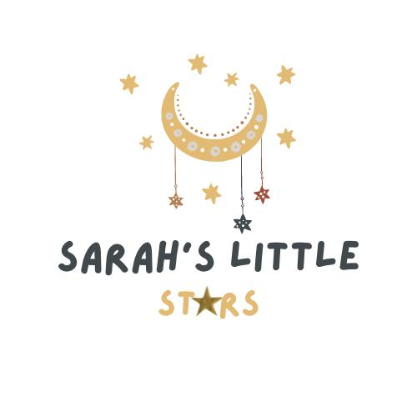

Consumables Policy

Purpose:
This policy outlines the provision and management of consumables at Sarah’s Little Stars. It ensures that all children have access to necessary materials and resources to support their care, learning, and development in a safe, hygienic, and inclusive environment.

Definition of Consumables:
Consumables include (but are not limited to):
- Nappies and wipes
- Sun cream
- Premium Arts and crafts materials (e.g., clay, charcoal, candle wax)
- Outings, excursions and special events (including public and private transport)
- Specialist tutoring (e.g. dance, animal man)

Provision of Consumables:
- Basic consumables necessary for daily care and learning activities are provided by the nursery.
- Parents are asked to provide specific items for their child where appropriate (e.g., specialist nappies, formula milk, prescribed creams).

Parental Contributions:
- An additional fee of £1.50 per day to cover consumables will be added in nursery charges. This will be clearly itemised in the invoice (Please note parents are able to opt out of this however, all consumables must be in new, sealed container for session the child attends).
- Parents will be notified of any changes to the consumables fee with at least 1 months’ notice.

Allergies and Special Requirements:
- Parents must inform the nursery of any allergies or sensitivities.
- We will accommodate specific needs wherever possible, including sourcing alternative products or requesting that parents provide specific items.

Hygiene and Safety:
- All consumables are stored and used in line with health and safety regulations.
- Staff are trained in the correct use and disposal of consumables such as gloves, nappies, and cleaning materials.
- We follow COSHH guidelines for the handling and storage of cleaning products.

Sustainability:
- Where possible, we source eco-friendly and sustainable consumables.
- We encourage waste reduction and recycling practices within the nursery.

Monitoring and Review:
- This policy is reviewed annually or sooner if needed due to operational changes or updated guidance.
- Feedback from staff and parents is welcomed to improve our use and management of consumables.

