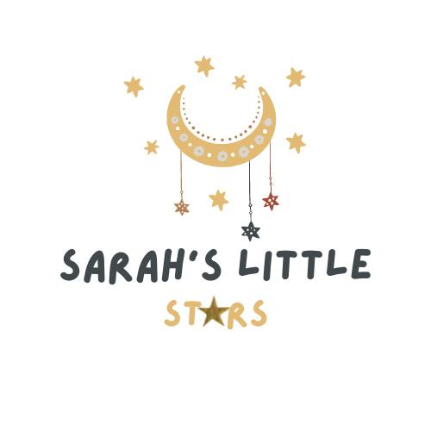

Fee Sheet September 2025 – March 2026

Opening Hours: 7:00am to 6:00pm
Opening Days: Monday to Friday

Operational Hours and Weeks:
We have a minimum of 2 full days attendance one of which must be a Monday or a Friday. The nursery is open all year 7:00am – 6:00pm apart from Bank holidays (Bank holidays are still chargeable, if that’s your child’s normal booked day), and a week at Christmas.

Whilst the Government funding is structured for 38 weeks of the year (term time), Sarah’s Little Stars is open for 51 weeks of the year therefore the funded hours are stretched over the weeks that we are open, please note funding is capped at 48weeks a year.
If your using funding over 38 weeks of the year (term time) then your will receive 30 hours a week and will follow the KCC Calander for term dates, if your using funding stretched across the year over 48 weeks, you will receive 22 hours funding per week,
Please note there is a mandatory five-day attendance for term time only.

There is no charge for the 15 hours Universal or 30 hours WPE.

The cost of the non-funded hourly rate is £9.75. Once we have claimed your funding in headcount week, we are unable to transfer it to another setting as we will have allocated staffing and ratios for that term. We will also not transfer funding if you are given notice for yours (the parents) or your child’s conduct.

Deposit: is £350.00. £300 of this will be deducted from your final invoice and £50 is kept as an admin fee. Please note, if you chose to retract your place prior to starting with Sarah’s little Stars the deposit is non-refundable.

This deposit does not apply to those in receipt of a fully funded space.

Standard Fees Per Month

Before funding is applied

 | Full Days Per Week 7am-6pm
 | 2 | 3 | 4 | 5
0-4 year olds | £911.62 | £1,367.43 | £1,823.25 | £2,279.06

Example of Fees with Early Years Funding Entitlement Applied Per Month
Please note, for 2-day plans, your entitlement is capped at 15 hours if term time or 12 hours if stretched and in line with your actual attendance. Our funded hours are delivered between 9:00am and 3:00pm if attending 2 days a week and 4pm if attending 3 or more days per week, Monday to Friday. Please not you can’t use 30 Hours if you only attend 2 days a week.

*Example after funding is applied

 | Days Per Week
 | 2 | 3 | 4 | 5
9mnths – 2yr (Working parent entitlement) | £405.54 | £423.93 | £807.50 | £1,280.96
2-3 year (Working parent entitlement) | £405.54 | £423.93 | £807.50 | £1,380.96
3-5 year (Working parent entitlement) | £612.00 | £752.44 | £1,099.17 | £1,480.65

Example of Term Time Fees with Early Years Funding Entitlement Applied Per Month
Please note, our term time placements are five days a week. Our funded hours are delivered between 9:00am and 3:00pm, Monday to Friday

9mnths – 2yr (Working parent entitlement) | £481.96
2-3 year Universal 15 hours | £1,092.18
2-3 years (Working parent entitlement) | £719.78
3–5 year Universal 15 hours | £1,210.93
3-5 year (Working parent entitlement) | £957.28

Working Parent Funding (WPF) Hours annually (15 hours) Universal 570 Hours annually (15 hours)
Universal and Working Parent Funding 1140 Hours annually (30hours)

Optional Extras

Description | Cost Per Day
Breakfast | £1.50
AM Snack | £1.50
Lunch | £3.50
Tea | £2.00
Consumables | £1.50

Whilst parents are welcome to provide their own meals and snacks. Please note that it is our policy for children to feel included during meal and snack time, so we do insist that parents prepare the same meals that other children will be eating. The menu will be made available to you in advance. We also require parents to print and sign a waiver for the food that they bring into the nursery to certify that none of the food contains allergens or have been prepared near allergens. If we do not have the signed waiver for each session, a charge will be applied to the next invoice.

Whilst parents are welcome to provide their own consumables, e.g. sun cream, wipes, nappies, nappy cream, Calpol, teething gels, Pirton etc.
We require that these items are brought in sealed for each session and collected after the end of each session. In the event that a parent does not bring the required consumables then, an additional charge of £1.50 will added to your invoice.

https://www.gov.uk/tax-free-childcare
https://www.gov.uk/check-eligible-free-childcare-if-youre-working

To secure you child’s space please make a £350 deposit to:

Sarah’s little stars LTD
Virgin business banking (will come up as Yorkshire banking)
Sort code 05-00-05
Account number 06404887
Please use your child’s name as the payment reference

Please note, if you chose to retract your place prior to starting with Sarah’s little Stars the deposit is non-refundable.

