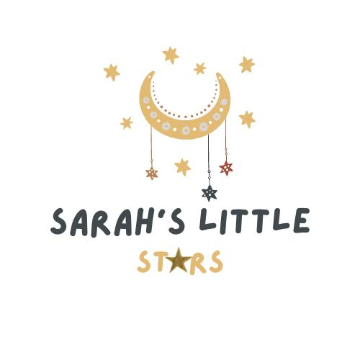

Nursery Funding Policy

Introduction:
This policy outlines how Sarah’s Little Stars delivers government-funded early education and childcare entitlements for eligible children aged 9 months, 2, 3, and 4 years. We are committed to ensuring that all children who are entitled to free early education can access it in a fair and transparent manner.
Government-Funded Entitlement:
We offer the following government-funded early education hours:
- 15 hours universal entitlement for all 9 months, 2, 3- and 4-year-olds, starting the term after they become elidable.
- 30 hours extended entitlement for eligible working families of 9 months, 2, 3- and 4-year-olds.
- 15 hours for eligible 2-year-olds, subject to qualifying criteria (income-based or SEND-related).
These entitlements are available for 38 weeks per year (term-time only) or can be stretched across the 48 weeks. Pease note, if your child is term time only you will receive 30 hours a week & you are required to attend 5 days a week and if your child is all year round it will be 22.8 hours a week.

Eligibility and Application:
Parents must check their eligibility and apply via:
- Childcare Choices website: https://www.childcarechoices.gov.uk
- Please note it is the PARENTS responsibility to renew their codes, HMRC send out a reminder, if you fail to renew on time, you will lose your funding and be charged full private paying fees. It is not the nursery’s responsibility to remind you to renew your own child’s code. I’m sure you can understand we look after over 140 families and with you all having different dates to renew, we simply just don’t have the time to do this.
Parents must provide:
  - A valid 30-hour code or eligible 2-year-old number
  - The child’s date of birth certificate or passport.
  - Any additional documentation required by the nursery or local authority.

Funding Periods:
Funding starts from the beginning of the term after the child becomes eligible and continues until they start school or no longer meet the criteria.

Terms start on:
  - 1st January (Spring term)
  - 1st April (Summer term)
  - 1st September (Autumn term)

Delivery of Funded Hours:
At Sarah’s Little Stars we aim to be flexible in how the funded hours are used:
- Funded hours can be accessed between 9:00 am – 3:00 (if two days a week) & 4.00pm (if 3 days plus a week)
- We offer the option to stretch funding across 48 weeks of the year or term time only 38 weeks of the year.
- If your child attends only two days per week, the number of funded hours that can be claimed will be capped at a maximum of 15 hours per week. If you are using the stretched funding offer (where the entitlement is spread across more weeks of the year), this cap is adjusted to 12 hours per week.
- If your child only attends 2 days a week, one of those days must be a Monday or Friday along with any other day of your choice (subject to availability)
- To access the full entitlement (e.g. 15 or 30 hours), additional attendance days may be required.
- We do not allow funding to be shared alongside another setting
- We do not transfer funding to another setting if you choose to leave during or after headcount has been submitted or if you the parent or child has been terminated for breach of conduct.
- In the event you are over allocated funding, KCC will contact us directly regarding this and those hours already used will then require being paid for by you the parent. We will always show you a copy of KCC email as proof where possible.

Charges for Additional Services:
The funded entitlement is free at the point of delivery. However, additional charges may apply for:
- Meals and snacks
- Extra hours outside the funded entitlement
- Nappies and wipes
- Enrichment activities (e.g., yoga, dance class, forest school etc)
- Premium arts and crafts (e.g., clay, charcoal, wax, wood work etc)
- Trips and 3rd party company activities (e.g., Animal man, Theatre trips, trips that involve public or private transport)
These charges are clearly outlined in our Fees Policy and will never be a condition of accessing the funded hours.

Invoicing and Transparency:
- Parents receive a monthly invoice showing funded hours and any additional costs.
- We ensure transparency so that families understand what is and isn’t covered by funding.
- Parents must sign a Parent Declaration Form each term to confirm their funding arrangements.
- Funded hours cannot be banked or carried over.

Changes in Circumstances:
Parents are responsible for informing the nursery of any change in their circumstances that may affect their entitlement. This includes:
- Loss of eligibility for 15/30 hours funding
- Change of address or childcare provider
- Termination of employment
If funding ends, parents will be liable for fees for any sessions attended.

Termination of Funded Place:
We reserve the right to withdraw a funded place if:
- The child does not attend regularly without a valid reason.
- False or misleading information was provided.
- The child moves to another provider or school.
- Immediate notice for yours or your child’s conduct

Complaints Procedure:
Parents can raise concerns through our Complaints Policy. If unsatisfied, they may also contact the local authority (KCC/ children’s information services).

