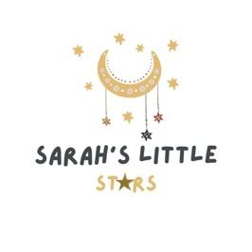

Phonics Policy

Intent

Here at Sarah’s Little Stars, we are passionate about ensuring that all children are given the necessary building blocks to ensure that they develop into fluent readers and writers. We also aim to embed a love of stories and reading.

Implementation:

Throughout their time at Sarah’s Little Stars, children will be taught Phase 1 Phonics. Phase 1 concentrates on developing children’s speaking and listening skills and lays the foundation for the teaching of Phase 2 Phonics and above.

Phase 2 Phonics is taught to the children who show an interest in reading and writing.

We believe that Phonics should be:

* Systematic
* Discrete
* Interactive
* Practical
* Engaging
* Multi-sensory
* Differentiated

Phonics lessons will be carried out in small groups, where they are taught age-appropriate Phonics in a fun, engaging way. Each Phonics session will have a consistent structure of revisit, teach, practise and apply.

During each session, they will:

* Revisit what they have already learnt,
* Be taught a new sound,
* Practise the new sound,
* Apply their new sound knowledge in games or fun activities.

We will use a wide range of multi-sensory resources including printed resources from Teacher Play Ltd.

The children will also be provided with a writing book, where they will practise their letter formation. They will also start having books sent home, starting with wordless picture books to be shared with you at home!

In order to assess progress, there will be short, fun assessments that the children will take part in. This will help assess any gaps in the children’s knowledge.

Pronunciation of sounds is crucial, so if you would like help with this do ask. There are also videos online that can help.